**Criteria for evaluating student learning outcomes**

**based on the general principles of the Academic Integrity League**

This document is aimed at improving the quality standards of teaching and evaluating students in accordance with the ESG-2015 standards, as well as at understanding the degree of compliance of organizations of higher and (or) postgraduate education (hereinafter - OHPE) with the standards of objective assessment applied to the League members. Following the improvement of the quality of teaching and transparency of student assessment is a priority of the members of the Academic Integrity League (hereinafter- the League). Compliance with these criteria, as well as the presence in the OHPE prescribed procedures for meeting these criteria, is an important practice for the members of the League.

** The criteria were developed by the League's Working Group based on the experience of higher education organizations and reputable universities (see bibliography).

**Basic provisions**

1. OHPE follows the principle of improving the quality of teaching and all its elements to unlock the individual capabilities of students.
2. OHPE follows the high academic standards of fair, transparent and unbiased assessment of students based on established assessment criteria.
3. OHPE has the right to choose independently the details and mechanisms for achieving and following the main provisions and evaluation criteria.

**Criteria:**

1. **Evaluation criteria** are clearly defined in the syllabus and the exam paper parameters under the current, intermediate and final evaluation of students.

a. The presence of evaluation criteria in syllabus section indicating all parameters of evaluation.

b. The presence of evaluation criteria in student's exam paper indicating all parameters of evaluation.

c. Examples of evaluation of current, intermediate and examination papers, indicating both the grades given for each parameter and the overall grade.

2. **Evaluation scale** - the breadth of OHPE teachers ' use of the full range of grades.

a. The frequency of OHPE's use of the entire range of available grades is from 0 % to 100 %.

b. Documented procedures for analyzing narrowly distributed grades.

c. Steps taken by OHPE to avoid analyzing grades based on the maximum average score or the maximum value % of student performance in favor of the analysis of the distribution of grades, the analysis of the median and standard deviation.

3. **Exclusivity of different evaluation** - a clear description in the guidelines and rules the exceptional parameters for assigning different grades from 90 % to 100 %.

a. Description of clear and exceptional characteristics in the learning regulations for a differential score of 90-100 %.

b. Statistics of various grades from 90 % to 100 % and their critical analysis in case of exceeding in 15% of cases.

c. Statistics of the awarding of the Diploma with Distinction and its critical analysis in case of excess in 5% of cases.

4. **Semester grade accumulation** - procedural rules for the student's accumulation of points in a discipline during the entire semester

a. Syllabuses of disciplines with the indication of specific maximum values of points for accumulation in the section of tasks and attestations.

b. The mechanism of the student's accumulation of grades during the entire period of study is specified in the learning regulations.

5. **Principles and procedures for evaluation analysis** - the mechanism and procedures for collecting data, analyzing, reviewing, and taking steps to improve the quality of teaching and grading.

a. The existence of procedures for analyzing grades and discussing them in academic departments.

b. The available examples (facts) of the analysis of deviations, such as a high value of the median, high value of the standard (root-mean-square) deviation, high variance of the number of individual grades from the normal distribution with a mechanism for their detection and elimination, which indicates the work of these procedures in OHPE.

c. OHPE's reported documented procedures for the exam session, which include the following parameters in the evaluation - the value of the median evaluation of academic structures, the value of the standard deviation of the normal distribution of grades, the difference in the number of grades submitted.

6. **The Bell Curve** is the main element of the statistical analysis of the quality of teaching and evaluation accepted in the League. To analyze the distribution of grades in OHPE and a large academic division of OHPE, a normal distribution diagram is constructed - the number of grades issued as a function of the digital score. To analyze the distribution of grades by teachers and small academic units of OHPE, a diagram of the normal distribution is constructed - the number of grades as a function of the letter grade as shown in the graph below.

a. Data on the results of the examination session in the form of a diagram of the normal distribution of the number of grades by numeric or alphabetic values of grades.

b. Data on the indicator median score of OHPE, academic unit, teacher (m).

c. Data on the indicator of the standard deviation of the distribution of OHPE grades, academic unit, teacher (σ).

d. Data on the variance of the deviation of the number of grades 90 and 70 points for OHPE, academic department, teacher (σ270 and σ290).

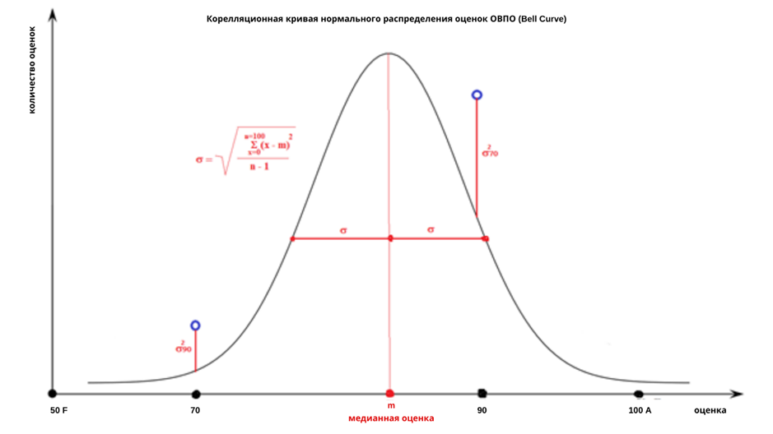

e. In the process of normal distribution on the Bell Curve, the grades are distributed in the following ratio:

"A", "A-" (90-100 %) - no more than 10% of the total number of students in the reference group;

"B+", "B", "B-" (75-89%) - no more than 25% of the total number of students in the reference group;

"C+", "C", "C-" (60-74%) - at least 30% of the total number of students in the reference group;

"D+", "D", "D-" (50-59%) - not less than 25% of the total number of students in the reference group;

"F" (0-49%) - not less than 10% of the total number of students in the reference group.

f. When evaluating all control activities, OHPE teachers stick to the above ratios, with the exception of small groups (less than 30 people) and disciplines included in the certification programs (ACCA, CFA, FRM, CIMA, HRCI, etc.)

g. Each case of deviations from the specified distributions of more than 5% should be the subject of analysis by the collegial bodies and the OHPE ensures that response measures are taken.

h. OHPE teachers are required to provide a methodological variety of control activities that allow a differentiated evaluation of the competencies of all students of the academic flow.

7. **Academic integrity of evaluation** - procedures for strictly adhering to the evaluation criteria when evaluating students' work and mechanisms for appealing grades that are not given according to the criteria.

a. Procedures and mechanisms of the regulations for evaluating current and attestation work.

b. The available examples (facts) of the decisions of the appeal disputes of students on the grades given not according to the stated evaluation criteria, which indicates the work of these procedures in OHPE.

8. **Distance learning technologies** - the use of distance learning technologies should not lead to a softening of the evaluation policy.

a. Strict adherence to the evaluation criteria adopted for the distance learning format.

b. Adherence to the principles of academic integrity, including electronic analysis tools and online proctoring to ensure compliance with the strict academic policy of OHPE.

**Recommendations:**

● OHPE-League members or candidates must seek to meet the above criteria or are on a path to achieving them.

● Adherence to the criteria of the League standard in the field of teaching quality and student evaluation is achieved by presenting to the League Council and to the General Meeting of the League members the requested materials and evidence of procedures for making recommendations and decisions.

● League members or candidates applying for membership in the League, as well as observers, provide materials to the League Council, the General Meeting of League Members and the League monitoring groups, such as anonymized factual data, samples of transcripts, curricula, syllabuses, electronic access to open documents regulating the academic activities of OHPE, and others.

**Bibliography**

1. Standards and Guidelines for Quality Assurance in the European Higher Education Area <https://enqa.eu/wp-content/uploads/2015/11/ESG_2015.pdf> (Accessed 27 February 2019).
2. Statutes and Ordinances of the University of Cambridge <https://www.admin.cam.ac.uk/univ/so/2018/chapter02-section19.html> (Accessed 28 February 2019).
3. Statutes and Ordinances of the University of Oxford. <http://www.admin.ox.ac.uk/statutes/> (Accessed 28 February 2019).
4. Student code of conduct of Nazarbayev University. <https://nu.edu.kz/wp-content/uploads/2017/11/NU-Student-Code-of-Conduct.pdf> (Accessed 28 February 2019).
5. [MIT Procedures for Dealing with Academic Misconduct and Dishonesty](http://web.mit.edu/policies/10/index.html). <https://policies.mit.edu/policies-procedures> (Accessed 28 February 2019).